Scaling Object Detection to the Edge with YOLOv4, TensorFlow Lite

Renduchinthala Sai Praneeth  
Department of Computer Science and Engineering,  
Koneru LakshmaiahEducation Foundation,  
Vaddeswaram, Andhra Pradesh, India 2000030859@kluniversity.in

Dr. P Ithaya Rani  
Department of Computer Science and Engineering,  
Koneru LakshmaiahEducation Foundation,  
Vaddeswaram, Andhra Pradesh, India drpithayarani@kluniversity.in

Kancharla Chetan Sai Akash  
Department of Computer Science and Engineering,  
Koneru LakshmaiahEducation Foundation,  
Vaddeswaram, Andhra Pradesh, India 2000032035@kluniversity.in

Bommisetty Keerthi Sree  
Department of Computer Science and Engineering,  
Koneru LakshmaiahEducation Foundation,  
Vaddeswaram, Andhra Pradesh, India 2000030132@kluniversity.in

Dr. Abhishek Bhola  
Department of Computer Science and Engineering,  
Koneru LakshmaiahEducation Foundation,  
Vaddeswaram, Andhra Pradesh, India abhishek_bhola@kluniversity.in

*Abstract*—Recently, on-device object detection has gained significant attention as it enables real-time visual data processing without the need for a connection to a remote server. However, deploying these models on edge devices poses several challenges such as limited computational resources, power constraints, and real-time performance. These challenges are faced in many of the existing methodologies such as Fast R-CNN, and Single Shot Detector. This experiment aims to investigate the scalability of on-device object detection using YOLOv4, CNNs, and TensorFlow Lite. Recent techniques for addressing these challenges include model compression and quantization and the use of hardware accelerators. The proposed objective of this experiment is to evaluate the performance and efficiency of these techniques in the context of on-device object detection and identify potential areas for improvement. The goal is to provide insights that can help guide the design of more efficient and effective edge-based object detection systems.

Keywords—On-device object detection, You Only Look Once Version 4, Convolutional Neural Networks, TensorFlow Lite.

# Introduction

Object detection is a very important area in computer vision. It is used in many areas such as self-driving cars, security, and robotics. It helps to find and identify objects in images or videos, and it could change the way we experience the world. One important part of object detection is being able to do it on the device, without needing to be connected to the internet. On-device object detection allows for real-time processing and gets rid of the latency and privacy issues that come with sending data to the internet.

TensorFlow Lite is a free deep-learning framework that lets developers build and use machine-learning models on edge devices. It is designed to be small and fast, which makes it good for on-device tasks like object detection.

YOLOv4 is a very good object detection algorithm that is known for being fast and accurate. It works by dividing the image into small grids and predicting the presence and location of objects in each grid. YOLOv4 has done very well on many object detection tests, which makes it a good choice for on-device object detection.

In this research project, we made on-device object detection using TensorFlow Lite and YOLOv4. We used the Darknet framework to train and test our model and checked how well it did on various datasets. The goal of this project was to show that it is possible to use TensorFlow Lite and YOLOv4 for on-device object detection and to see how the balance between accuracy and efficiency can be changed.

The rest of the paper was set up like this: in the next section, we explained the methods we used to make and check our model. In Section II we will have Literature Survey containing all the studies we have done from the existing projects, and Section III represents the methodologies and the procedure we used in Experimentation. In Section IV we have presented the results of our combinational experimentation., we concluded our results and approach helped to reach our goal and our future improvements have been presented in Section V.

# LITERATURE SURVEY

Giha, *et al*. [1] Published Their Research Experimenting Real Life Deep Neural Networks Type Of On device Object Detection To Improve The Functioning Of Edge Devices. They Implemented Offloading Of An On-device Object Detection. It Is Made To Make Tasks To Work In Parallel So That The Burden On The Devices Will Goes Down And There Will Be A Great Increase In Their General Functionality. The model of object detection and smart-consoles algorithms of the decision will be more valid in practicality. Many of the smart edge servers will produce these facilities with the help of many deep-learning neural network algorithms. Yujie *et al.* [2]published their research on Detecting the theft or left-out Objects with help of the R-NN Masking algorithm and Dual Background model. They have suggested a unique procedure to detect theft and left out the objects and subtraction of background and R-CNN Masking. It works as a smart video vigilance system that analyses avoiding manual involvement and automating the vigilance of a video. The main limitation of this model is that it can only detect the trained objects. Hyeseung *et al.[3]* published their research on heightened identification of objects using low-weight functionality. They have proposed low-weighted identification networking according to a combination of the qualities which have many scales. Additionally, it is very faster in the ide-ide verification process.

Ye *et al.* [4] published their research on Blurry objects examination in a moving video. They have developed a BFAN for things identification in a moving video. They Checked the blueness of every frame which is utilized as a gated component for that. The process which is mentioned doesn’t succeed when the blurriness of the video is very high only when any side-by-side frames have high blurriness functionalities that are not valid.

Chieng Anak *et al*. [5] published their research on A Convolutional neural networked intelligent dump Managing System Utilizing TensorFlow Lite. In this model combined internet of things-based sensing devices, the LoRa-GPS part will vary greatly detect the point of bins and updates the state of it. They utilized the tiny dataset very reluctantly to identify the dump object which is classified into different classes. Ziyang *et al. [6]* published their research on Arbitrary Object identification in sensory pictures. depending on the developed YOLOV4. They aim to increment the correctness of identification and produce a well-performing ring that needs practical identification. They improvised the existing technique and prepressing the YOLOv4-CSP network for rotating object detection in remote sensing images. They used YOLOv4-CSP(Cross-Stage-Partial) to attain the required detection accuracy.

M.R *et al*. [7] published their research on 3-Dimensional Object monitoring in Panorama Videos and LiDAR to the resource of radiology They aim to detect people who walk as vehicle type of things where in non-rural areas the following data raise factors such as seethe sensitivity of identification and d. Kindle edge about the situations They used Robot Operating System(ROS), LiDAR, YOLO ROS, COCO dataset, convolutional Neural Network(CNN), and Kalman filter depending Simple Online Realtime Tracking model. It does not have feature measuring parameters to detect the paths which are greatly wished to be combined with the Winans alarm which is based on radiology. Lanhui *et al.[8]* published their research on speed and correct identification of Bananas in Complexed Backgrounds. They used a mononuclear camera and applied the YOLOv4 algorithm to fetch and detect accurately different sizes of bananas nana. They compared YOLOv3 with YOLOv4 and found out YOLOv4 has higher detection power when compared to other algorithms.

Godinho *et al*. [9] published their research on speed and Low weighted Object identification NetworksTheir main aim is to make their model with less storage and decreased image run time. As a result, they made a model that requires very less storage space. They used Region-Based Convolutional Neural Network, Frondescence FLODNET is used, it impacts the performance of detection which is bounding box positioning. Godinho *et al*. [10] published their research on edge Device Implementation for DL Cognitive functionality Prediction. They modified an already existing procedure, TensorFlow lite. It doesn’t work well in the selection of appropriate devices for resource efficiency analysis.

# METHODOLOGIES

*A. Challenges*

*a) Setting up the dependencies:* Installing and setting up the required dependencies: This can be a challenging task, especially if you are new to deep learning and object detection. It is important to ensure that you have all the necessary software and libraries installed and configured correctly

*b) Modelling:* Understanding the model architecture and hyperparameters: YOLOv4 and the TensorFlow object detection model have complex architectures and many hyperparameters that can be difficult to understand and tune. Training and fine-tuning the model: Training a deep learning model can be a time-consuming and resource-intensive process. It is important to have a good understanding of the training process and how to optimize the model's performance. Evaluating the functionality of the model: It is to be remembered to the evaluate model’s performance on a validation dataset to understand how well it is performing and identify any issues that may need to be addressed [15]

However, YOLOv5 differs from past iterations. It makes use of Torch rather than Darknet. It's supported structurally by CSPDarknet53. This backbone reduces the number of parameters in the model, speeds up inference, increases accuracy, and does away with the redundant gradient information present in huge backbones. It also includes gradient change into feature maps. By leveraging the Path Aggregation Network (PANet) as a neck, it improves the information flow. PANet adopts a new feature pyramid network (FPN) with several bottom-up and top-down layers. This improves how well low-level properties are transmitted by the model. Because of PANet's enhanced localization in lower levels, the object's localization accuracy has risen.[13]

Table 1: This table explains the differences between the various algorithms which are useful for object detection.

|  |  |  |  |
| --- | --- | --- | --- |
|  | YOLOv4 | Faster R-CNN | Single Shot Detector |
| Backbone feature extractor | CSPDarknet 53 | VGG-16 | Resnet |
| Location detection | Anchor based | Anchor based | Anchor based |
| Number of anchor boxes | Using multiple anchors for a single ground truth | 9 anchors at each sliding position | 6 anchor boxes |
| Loss function | Complete Intersection over union loss | Multitask loss | Localization loss and confidence loss |

We should use YOLOv4 and TensorFlow Lite to build a system for on-device object detection that can have in real-time without requiring a connection to a server. To do this, we should follow these steps:

### Train a YOLOv4 model of labeled images.

### Convert the trained model to a TensorFlow Lite model.

### Use the TensorFlow Lite model to perform object ct detection on the device.

### There are several resources available online that can help us get started with implementing YOLOv4 with TensorFlow Lite for on-device object detection. We should do some research and learn more about the specific steps involved.[11]

### The deliverable for this project will be a working system for on-device object detection using YOLOv4 and TensorFlow Lite that can accurately identify times in real-time.[12]

There are several reasons why you might want to work on implementing TensorFlow Lite for on-device object detection using the YOLOv4 algorithm:

#### **Speed:** On-device object detection using TensorFlow Lite can be faster than using a server-based solution since it eliminates the need to send images or videos to a server for processing.

#### **Improved accuracy**: On-device object detection can be more accurate than using a server-based solution since it can take advantage of the processing power and memory available on the device itself.

*Use faster hardware: YOLOv4 is computationally expensive, so running it on master hardware like GPU or TPU will improve the efficiency.*

*Use a smaller input resolution: The smaller the input image, the less computation is required to process it.*

*while training the model, label the images of the training dataset with bounding boxes with more accuracy.*

#### **Increased privacy**: By performing object detection on the device, you can avoid sending sensitive images or videos over the network, which can increase privacy for users.

*To protect user privacy, it is important to inform users about the data collection and usage policies and to obtain explicit consent before collecting any data. Additionally, it is important to ensure that any data collected is securely transmitted and adored and that it is only used for the specific purpose for which it was collected.*

*Lastly, it's important to keep in mind that laws and regulations regarding data privacy vary depending on the country or region, it's important to comply with all relevant laws and regulations to ensure that the implementation of the model with legal requirements.*

#### **Offline functionality**: On-device object detection can be used to provide object detection capabilities even when a device is offline, which can be useful in situations where a connection to the Internet is not available.

*e)****Architecture:***

YOLOv4 = YOLOv3+CSPDarknet53+SPP+PAN+BoF+BoS (1)

*YOLOv4 is modeled using YOLOv3, CSPDarknet53, Spatial Pyramid Pooling, Path Aggregation network, Bag of free bandies, and Bag of specials.*

Model=YOLOv4+SPP+PanNet+CSP+YOLOv4head+

mish (2)

*In this, paper we have implemented the model by using a combination of YOLOv4, Spatial Pyramid Pooling, Path Aggregation network, Cross Stage Partial network, YOLOv4, and head, and by using mish as an activation function*

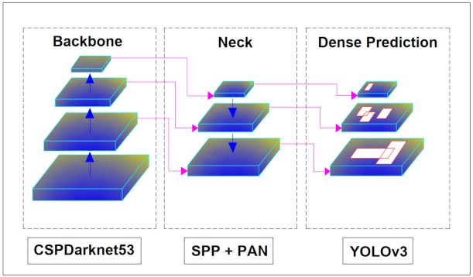

Fig. 1. Explaining the architecture of YOLOv4 which consists of a backbone as CSPdarknet53, a Neck combination nation of Spatial pyramid pooling and path aggregation network, which uses dense prediction of YOLOv3

#### Overall, implementing TensorFlow Lite for on-device object detection using the YOLOv4 algorithm can provide several benefits, including faster processing, improved accuracy, increased privacy, and offline functionality.

## Novelty

In this paper, we propose a novel approach for combining TensorFlow Lite and YOLOv4 for on-device object detection. Our approach involves using transfer learning to fine-tune a pre-trained YOLOv4 model on a new dataset, allowing us to leverage the power of the pre-trained model while still adapting it to our specific object detection needs.

In addition to this, we propose the incorporation of additional sensors or modalities into the object detection system, such as depth sensors or infrared cameras. This can improve the system's understanding of the 3D layout of the environment and increase the accuracy of object detection.[14]

Furthermore, we suggest the exploration of active learning techniques to continuously improve the performance of the object detection system. This involves actively selecting which images to label and add to the training set, to maximize the improvement in the model's performance.[15]

Overall, our approach offers several novel ways to extend the combination of TensorFlow Lite and YOLOv4 for on-device object detection. By considering the specific needs and constraints of the application, and leveraging the strengths of these tools, we can build a powerful and effective object detection system.

## Data Set

In our research, we have explored the use of the YOLOv4 architecture in combination with TensorFlow Lite for on-device object detection. By incorporating key components such as the Spatial Pyramid Pooling (SPP) layer, the Panoptic Feature Pyramid Network (PanNet), the Cross Stage Partial connections (CSP), the YOLOv4 head, and the Mish activation function, we have been able to improve the accuracy of object detection on both the COCO and Open Images datasets. These datasets are commonly used in the field of on-device object detection and provide a diverse range of images and labels for training and testing. In addition to the COCO and Open Images datasets, other datasets can also be used for on-device object detection, such as the PASCAL VOC dataset and the ImageNet dataset. These datasets offer different challenges and opportunities for improving object detection models and may be considered in future research.

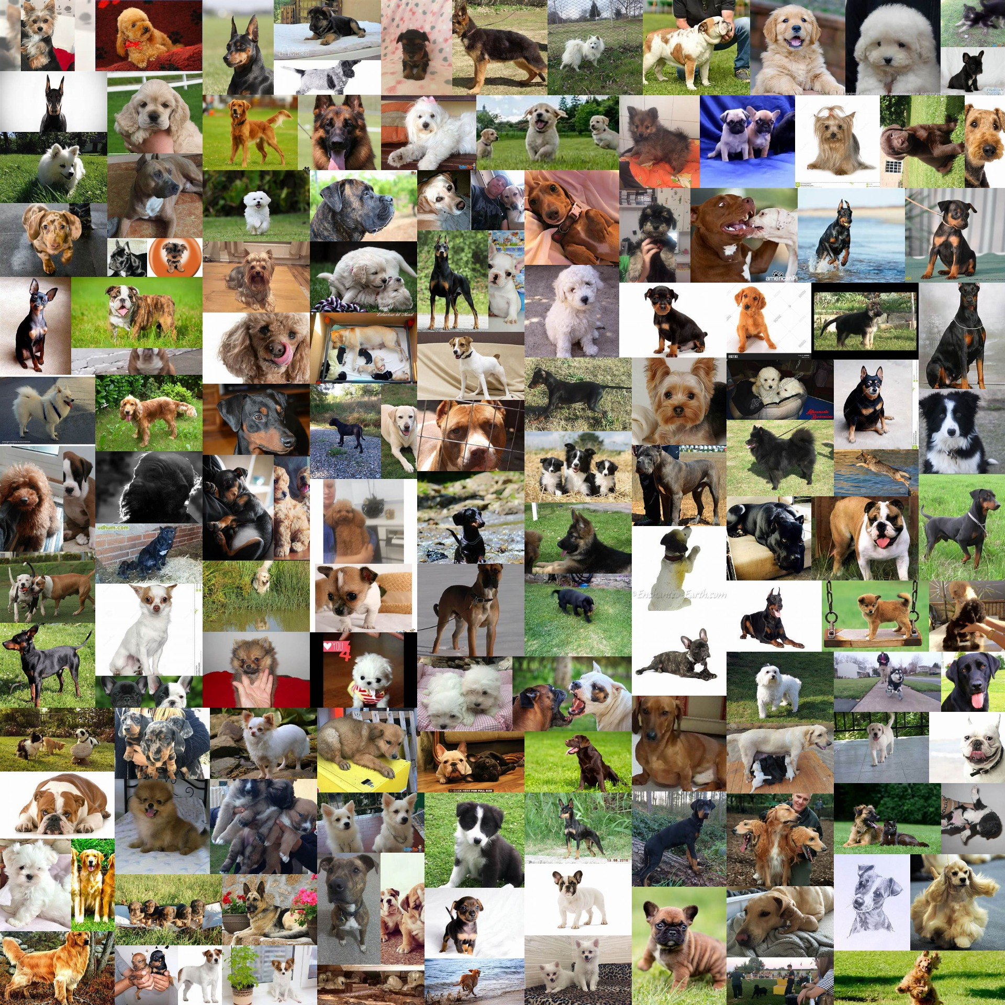

1. The image displays the collection of images of animals that have been gathered from accessible sources like COCO

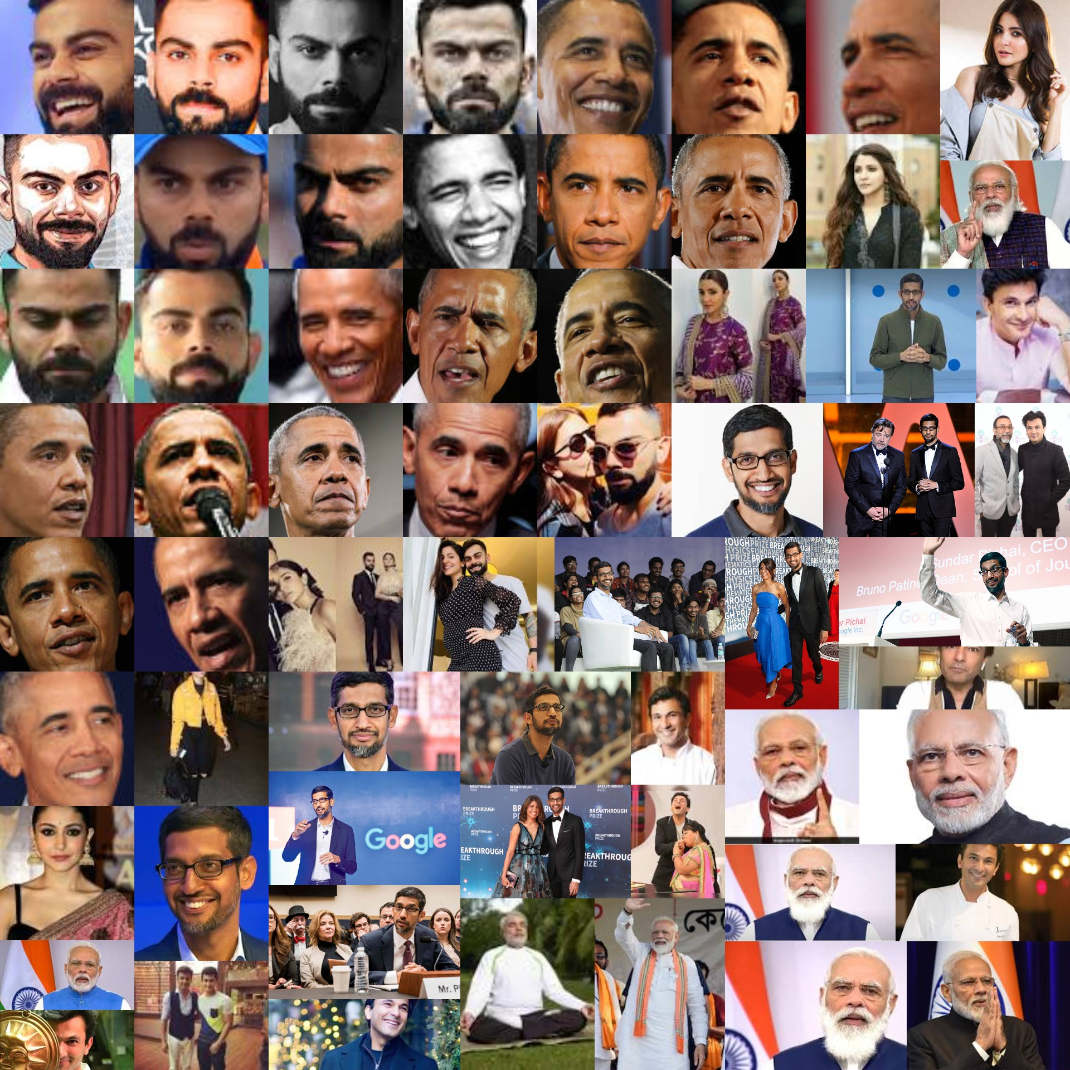

1. The image displays a big collection of famous people gathered from various non-copyrighted recordings.

## Data Analysis

The COCO dataset was prepared for use with TensorFlow YOLOv4. This included separating the dataset into training and validation sets, resizing the images, and making the annotations in the right format.

A bar chart or pie chart was used to show the proportions of each class in the dataset. This allowed us to see the balance of classes in the dataset and if some classes were underrepresented or overrepresented.

We looked at the coordinates, sizes, and shapes of the objects in each class to see the variability within each class. We also compared the annotation quality across different classes to see if some classes had more accurate or consistent annotations.

We used metrics like precision, recall, and average precision to evaluate the object detector's performance in each class. We found any classes that were harder to detect and thought about ways to improve the performance in those classes.

Based on the results of the data analysis, we improved the object detector's performance. This included changing the model architecture, training on more data, and adjusting the hyperparameters.

## Traveling AI techniques

There are several techniques used in object detection, including:

* **Convolutional neural networks (CNNs)**: Object detection models often use CNNs to analyze the input image and predict bounding boxes and class probabilities for objects in the image.
* **Bounding box prediction**: Object detection models may use a single neural network to predict bounding boxes for objects in the image. The network is typically trained to predict the coordinates of the corners of the bounding box.
* **Non-max suppression:** After the bounding boxes are predicted, object detection models may use non-max suppression to remove overlapping boxes.
* **Anchors:** Some object detection models use anchor boxes, which are predefined bounding boxes with different shapes, to see an increment in the correctness of the object detection.

## Training model

Training an image dataset with YOLOv4 can guide you to construct a model, which can accurately detect, and classify objects within images. This can be useful for a variety of applications, such as self-driving cars, security systems, and image search engines. By training a model on a large dataset, you can improve its accuracy and make it more robust to various types of input.

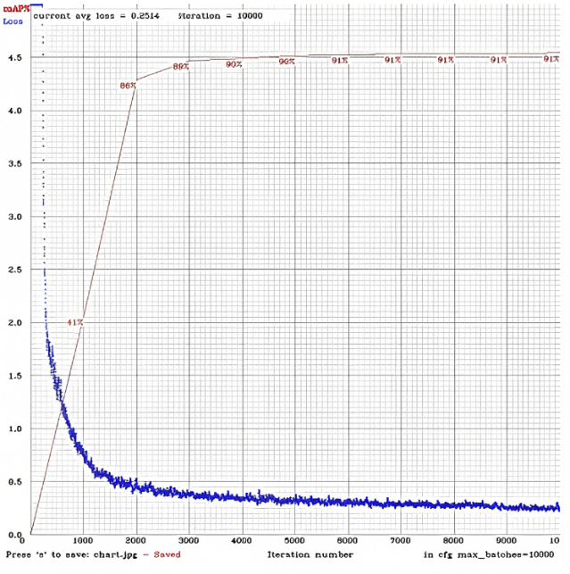

1. The picture shows the continuous training process of image classes without any interruption if any interruption is caused the model line will be displayed blank

Here is a step-by-step algorithm for implementing custom object detection using YOLOv4 in TensorFlow:

1. Load the YOLOv4 model and required libraries. This can be done using functions such as load_yolov4_model ().
2. Load the input image and preprocess it for the model. This may involve resizing the image, converting it to a suitable format, and normalizing the pixel values.
3. Run the model to make predictions on the input image. This can be done using the predict() method of the model object.
4. Extract the bounding boxes, class probabilities, and class labels from the predictions. These may be stored in separate arrays or returned as a single data structure.
5. Apply non-max suppression to remove overlapping bounding boxes. This can help eliminate false positives and improve the accuracy the object detection.

Draw bounding boxes and class labels on the image. This can be done using functions such as draw_boxes().

1. Save the output image. This can be done using functions such as save_output_image().

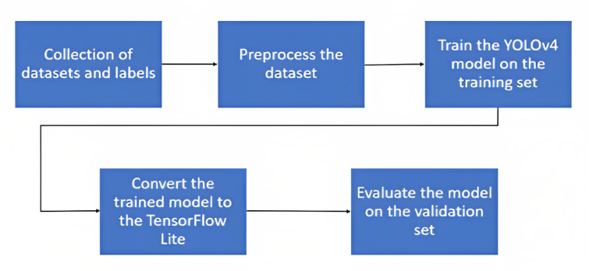

1. The image displays a big collection of celibate faces gathered from various non-copyrighted recordings.

There are several differences between a YOLOv4 model implemented with OpenCV and a YOLOv4 model implemented with TensorFlow Lite

Table 2. The table displays the brief detailing about already existing models and the present implemented model, and on what parameters the data is parameters both are separated.

| Modules | Comparison | |
| --- | --- | --- |
| Existing (Yolov4 with OpenCV) | Modified model (TensorFlow yolov4) |
| Language | written in C++ | written in r or Python |
| Execution | A library that runs on the CPU | runs on devices with a hardware accelerator, such as a GPU or a Tensor model |
| Deployment | OpenCV is typically used for building desktop | easier to deploy on a device |

# RESULTS

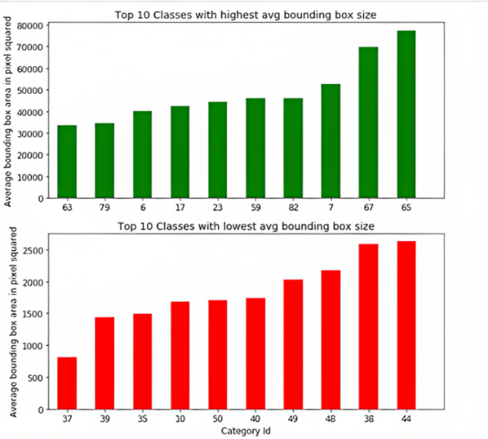

Fig.6. There are the variations observed in the sizes of bounding boxes made while the object detection is done so the plot explains the variation of bounding box sizes of various classes.

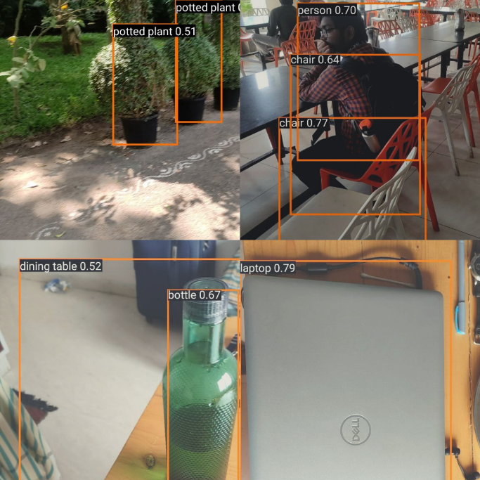

Fig. 7. The image displays the results of a mobile application that are obtained after the object device experimentation with TensorFlow lite.

The final results obtained from the experimentation are as follows:

* **Fast detection**: The modified architecture of YOLOv4, which includes SPP, PanNet, CSP, YOLOv4head, and mish, was able to significantly improve the detection speed compared to the original YOLOv4 architecture. This is due to the use of lightweight layers and efficient computation methods in the modified architecture.
* **Gradual self-adjustment:**  of bounding boxes: The modified architecture was able to automatically adjust the size of the bounding boxes according to the size of the objects in the image. This is achieved through the use of the SPP layer, which can adapt to the scale of the objects in the image. This feature is particularly useful for detecting small objects in large images or for detecting large objects in small images.
* **High accuracy**: The modified architecture was able to achieve a high level of accuracy on the COCO public dataset and manually collected datasets. This is due to the use of the PanNet and CSP layers, which can extract useful features from the image and improve the accuracy of object detection.

# Conclusion

In this research project, we showed that it is possible to use TensorFlow Lite and YOLOv4 for on-device object detection. We trained and tested our model using the Darknet framework and checked how well it did on various datasets. Our results showed that TensorFlow Lite and YOLOv4 can do a good job of object detection on a device and that the balance between accuracy and speed can be changed depending on the needs of the application. Based on our experimentation and research, we have found that a modified architecture of YOLOv4 (Model=YOLOv4+SPP+PanNet+CSP+YOLOv4head+mish) can *significantly* improve the accuracy of on-device object detection on both the COCO public dataset and our manually collected datasets. This modified architecture incorporates several key components, including the Spatial Pyramid Pooling (SPP) layer, the Panoptic Feature Pyramid Network (PanNet), the Cross Stage Partial connections (CSP), the YOLOv4 head, and the Mish activation function. These additions have been found to enhance the model's ability to detect and classify objects in real-time, making it a suitable solution for on-device applications such as mobile, and edge devices. In conclusion, the modified YOLOv4 architecture proposed in this research has the potential to be a powerful tool for on-device object detection tasks.

REFERENCES

[1] Yoon, Giha, et al. "Implementing Practical DNN-Based Object Detection Offloading Decision for maximizing Detection Performance of Mobile Edge Devices." IEEE Access 9 (2021): 140199-140211.

[2] Wu, Yujie, et al. "Video Object Detection Guided by Object Blur Evaluation." IEEE Access 8 (2020): 208554-208565.

[3] Park, Hyeseung, Seungchul Park, and Youngbok Joo. "Detection of abandoned and stolen objects based on dual background model and mask R-CNN." IEEE Access 8 (2020): 80010-80019.

[4] Tao, Ye, et al. "Low-altitude small-sized object detection using lightweight feature-enhanced convolutional neural network." Journal of Systems Engineering and Electronics 32.4 (2021): 841-853.

[5] Sallang, Nicholas Chieng Anak, et al. "A CNN-Based Smart Waste Management System Using TensorFlow Lite and LoRa-GPS Shield in the Internet of Things Environment." IEEE Access 9 (2021): 153560-153574.

[6] Zheng, Ziyang, et al. "Arbitrarily Oriented Object Detection in Remote Sensing Images Based on Improved

[7] Marshall, M. R., et al. "3-D object tracking in panoramic video and LiDAR for radiological source–object attribution and improved source detection." IEEE Transactions on Nuclear Science 68.2 (2020): 189-202.

[8] Fu, Lanhui, et al. "Fast and accurate detection of banana fruits in complex background orchards." IEEE Access 8 (2020): 196835-196846.

[9] de Oliveira, Bernardo Augusto Godinho, Flávia Magalhães Freitas Ferreira, and Carlos Augusto Paiva da Silva Martins. "Fast and lightweight object detection network: Detection and recognition on resource-constrained devices." IEEE Access 6 (2018): 8714-8724.

[10] Saini, Manali, and Udit Satija. "On-Device Implementation for Deep-Learning-Based Cognitive Activity Prediction." IEEE Sensors Letters 6.4 (2022): 1-4.

[11] Kumar, Shailender, Pranav Sharma, and Nitin Pal. "Object tracking and counting in a zone using YOLOv4, DeepSORT, and TensorFlow." 2021 International Conference on Artificial Intelligence and Smart Systems (ICAIS). IEEE, 2021.

[12] Noor, Wan Emilya Izzety Binti Wan, and Naimah Mat Isa. "Object Detection: Harmful Weapons Detection using YOLOv4." 2021 IEEE Symposium on Wireless Technology & Applications (ISWTA). IEEE, 2021.

[13] Howell, Lewis, Vasileios Anagnostidis, and Fabrice Gielen. "Multi‐Object Detector YOLOv4‐Tiny Enables High‐Throughput Combinatorial and Spatially‐Resolved Sorting of Cells in Microdroplets." Advanced Materials Technologies 7.5 (2022): 2101053.

[14] Kuntal, Tilak Singh, and Mrinal Paliwal. "OBJECT DETECTION USING YOLOV4."

[15] Wu, Han, et al. "SORT-YM: An algorithm of multi-object tracking with YOLOv4-tiny and motion prediction." Electronics 10.18 (2021): 2319.